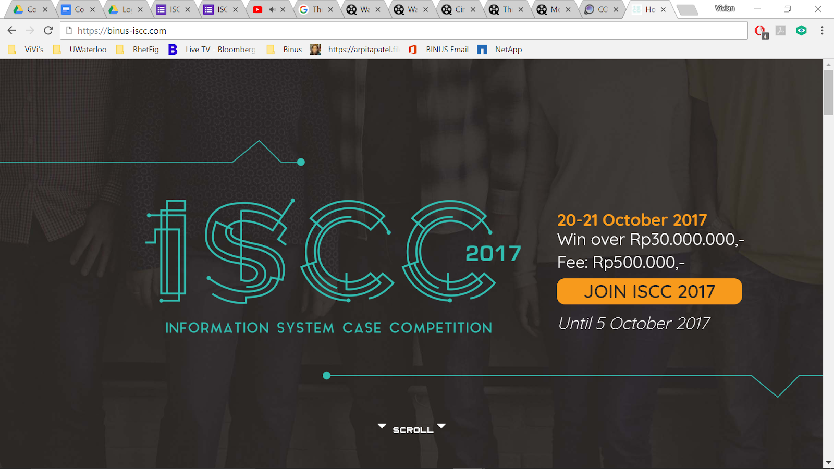

ISCC 2018

Now Welcoming Teams from High School and University!!!

21 August - 5 October 2018

Win Over Rp 45,000,000

Fee starts from: 120,000

Join ISCC Button (Link: <https://docs.google.com/forms/d/18TuDVe0zTBMKAwI-JkpT530J5cvrK5cjmrZDOlJi-M4/prefill>)

Latest by 20 August 2018

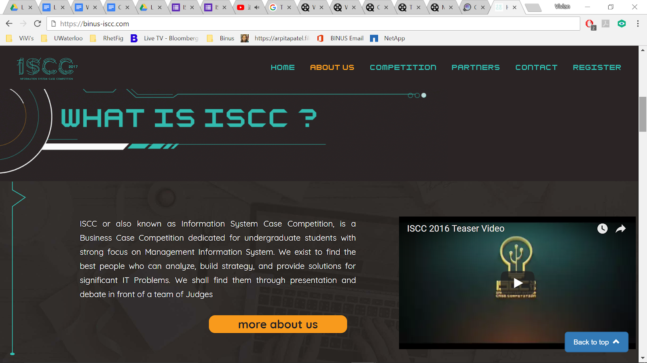

**What is ISCC?**

The annual Information System Case Competition organized by BASIS of Binus International is back!! Since its inception in 2014, ISCC has developed a reputation to become one of the most highly coveted case competitions in Indonesia, attracting the attention of top ranked universities from Indonesia and Malaysia. Participants compete on solving information system related cases designed by world class institutions and corporations that encompasses an array of relevant problems of in modern day society, encouraging participants to innovate in order to bring their best solution. In proportion to the quality cases, the competition will be judged by local and foreign Industry Experts and professionals.

ISCC is renowned for its ability to provide quality cases that challenge participants to think critically and produce an innovative solution that can be applied in the real world. ISCC has also been highly praised by lecturers from other universities in providing useful cases which were utilized for their teaching materials in addition to being a platform for students to showcase their abilities in solving real-world cases. This year, ISCC is back with more challenging cases and more exciting competition structure.

**What is the Case about?**

Participants will be provided with current ongoing cases, created by the industry professionals, related with ***Healthcare*** system in Indonesia. **Business Information System itself can be defined as the use of technology to improve business performance and support a company’s strategic planning.**

VIDEO: minta rudy wkwk

Case Partner: Deloitte

Timeline di gambar kek gini

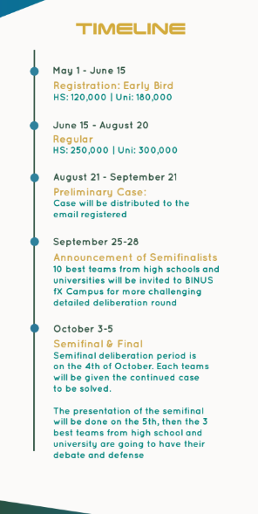

**Contact Person**

* BASIS Official Line: @utk9300d (with @)
* BASIS Official Email: [basis.binusinternational@gmail.com](mailto:basis.binusinternational@gmail.com)